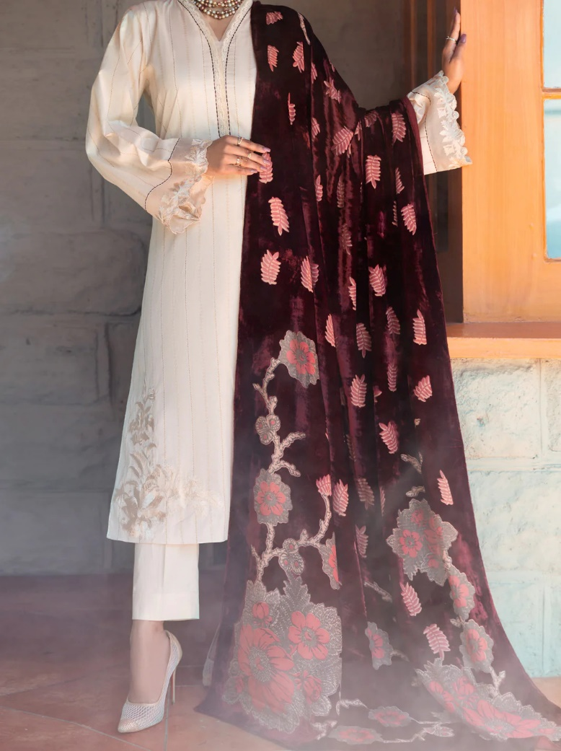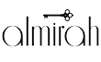

PINK 3 PIECE BLENDED STITCHED - ALP-3PS-1665

Sale priceRs.10,687.50

ADDITIONAL INFO

|  |  |
| --- | --- |
| **Color** | Pink |
| **Pieces** | 3 Pieces |
| **Fit Type** | — |
| **Fabric** | Blended, |
| **Season** | Winter Collection |
| **Disclaimer** | Due to the photographic lighting & different screen calibrations, the colors of the original product may slightly vary from the picture. |